**First C++ Program**

**1) What is Programming Language?**

Programming Language is a way to communicate with a computer. It is a formal language which consists of set of strings that produce various kind of machine input.

Every programming language must be written following some rules called **Syntax** of that language.

A computer essentially understands only binary code of 0s and 1s. A compiler processes the statements of a programming language into the Machine Code (Binary Number System).

**Ex:** C, C++, Java, Python, R, Go etc.

**2) How does C++ compiler work?**

C++ compiler work as follows.

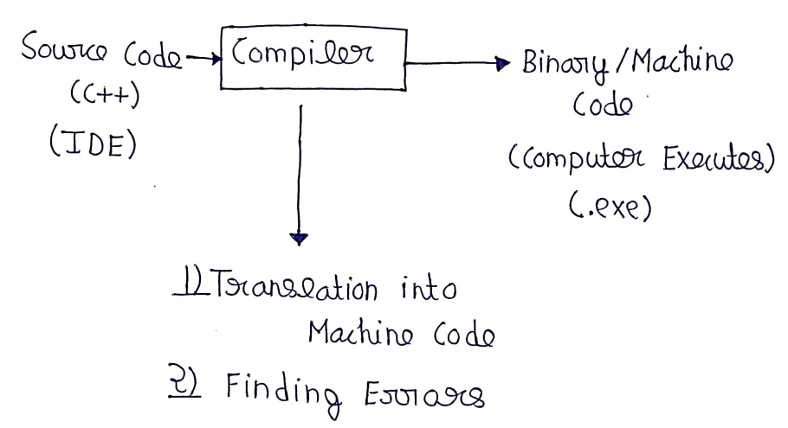

**3) First C++ Program:**

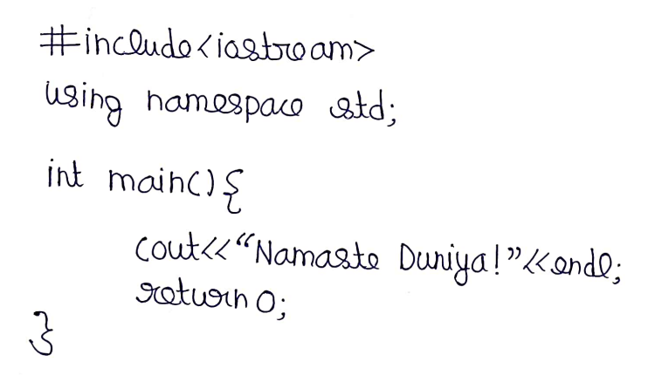

**4) What are Data Types & Variables?**

Variables are the memory locations which is used to store data in C++ and data types decide what kind of data variable can hold.

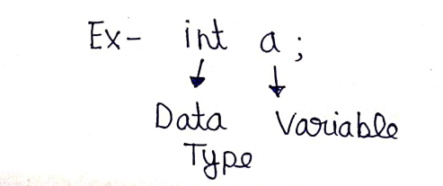

**5) Unsigned Data Types:**

By default, the data types are signed means we can store both positive and negative data in the variable but we can change it as it as an unsigned as follows.

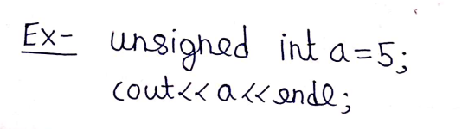

**6) Data Types and their Sizes:**

There are mainly five primitive data types in C++.

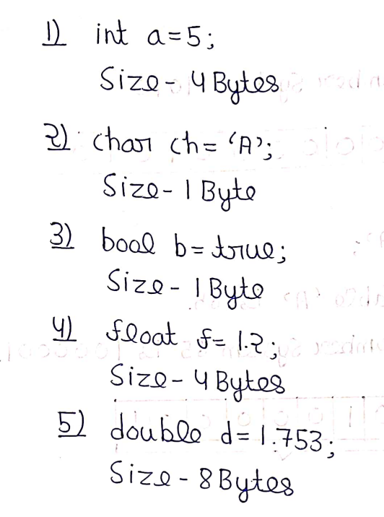

**7) Size of Operator in C++:**

Size of Operator is used to find the size of a variable in bytes in C++.

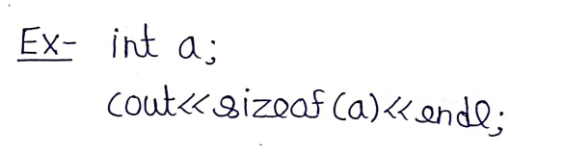

**8) How data stored in memory?**

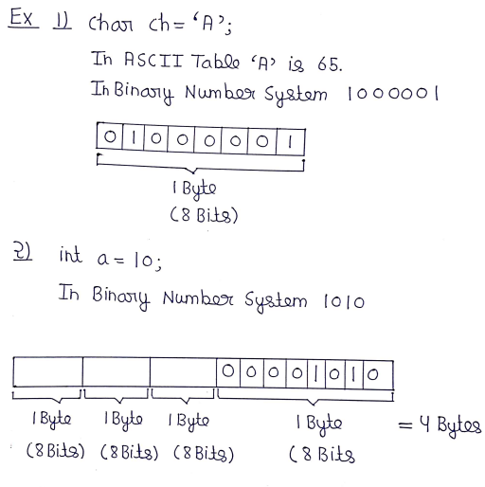

**9) How negative number is stored in memory?**

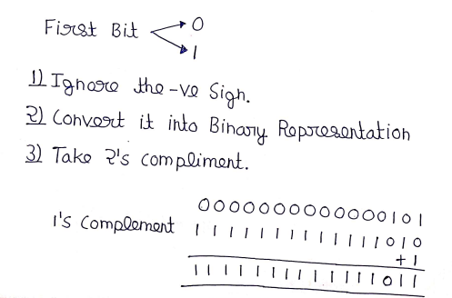

**10) Operators in C++:**

Operators are special symbols or characters that perform specific operations on one or more values or variables. In C++, there are mainly five types of operators.

**Arithmetic Operators:** +, -, *, /, %

**Relational Operators:** ==, !=, >, <, >=, <=

**Assignment Operators:** =, +=, -=, *=, /=, %=

**Logical Operators:** &&, ||, !

**Bitwise Operators:** Here we skip Bitwise Operators, we will study Bitwise Operators while learning BIT Manipulation.